**Case Study on IP Address and Problem Solving**

What is IP Address?

An IP address is a string of numbers separated by periods. IP addresses are expressed as a set of four numbers — an example address might be 192.158.1.38. Each number in the set can range from 0 to 255. So, the full IP addressing range goes from 0.0.0.0 to 255.255.255.255.

IP addresses are not random. They are mathematically produced and allocated by the Internet Assigned Numbers Authority (IANA), a division of the Internet Corporation for Assigned Names and Numbers (ICANN). ICANN is a non-profit organization that was established in the United States in 1998 to help maintain the security of the internet and allow it to be usable by all. Each time anyone registers a domain on the internet, they go through a domain name registrar, who pays a small fee to ICANN to register

- All devices that are connected to an internet connection have a unique IP address which means there’s a need of billions of IP addresses. This requirement is fulfilled by the new IP version IPv6. **-** There are two IP versions: **IPv4** and **IPv6**. IPv4 is the older version which has a space of over 4 billion IP addresses. However, the new IPv6 version can provide up to trillions of IP addresses to fulfill the need of all internet users and devices.

**-** The IPv4 version used to configure IP addresses in numerical value (numbers) which may conflict with other IP addresses. That’s why IPv6 adopted the hexadecimal method to provide unique IP addresses to billions of users in the world.

**-** Example of an IPv6 IP address would be: **4ggr:1925:5656:7:600:t4tt:tc54:98vt –**

There are a few types of IP addresses like **private IP addresses, public IP addresses, static IP addresses and dynamic IP addresses**.

**Private IP Address**

**-** A private IP address is the address of your device connected on the home or business network. **-** If you have a few different devices connected to one ISP (Internet Service Provider), then all your devices will have a unique private IP address.

**-** This IP address cannot be accessed from devices outside your home or business network. **-** For example: **192.168.1.1**

**-** Private IP addresses are not unique because there are limited number of devices on your network.

**-** You can find out the private IP address of your device. If you are a Windows user, then simply go to the command prompt and enter the command ipconfig. If you’re a mac users, then you need to enter the following command ifconfig in your Terminal app

**-** If you are using the internet on a mobile phone, then you can go to your WiFi settings to find out the IP address. iOS users can find the IP address by clicking on the ‘i‘button next to the network they are connected to. Android users can click on the network name in their WiFi settings, and it will show the IP address.

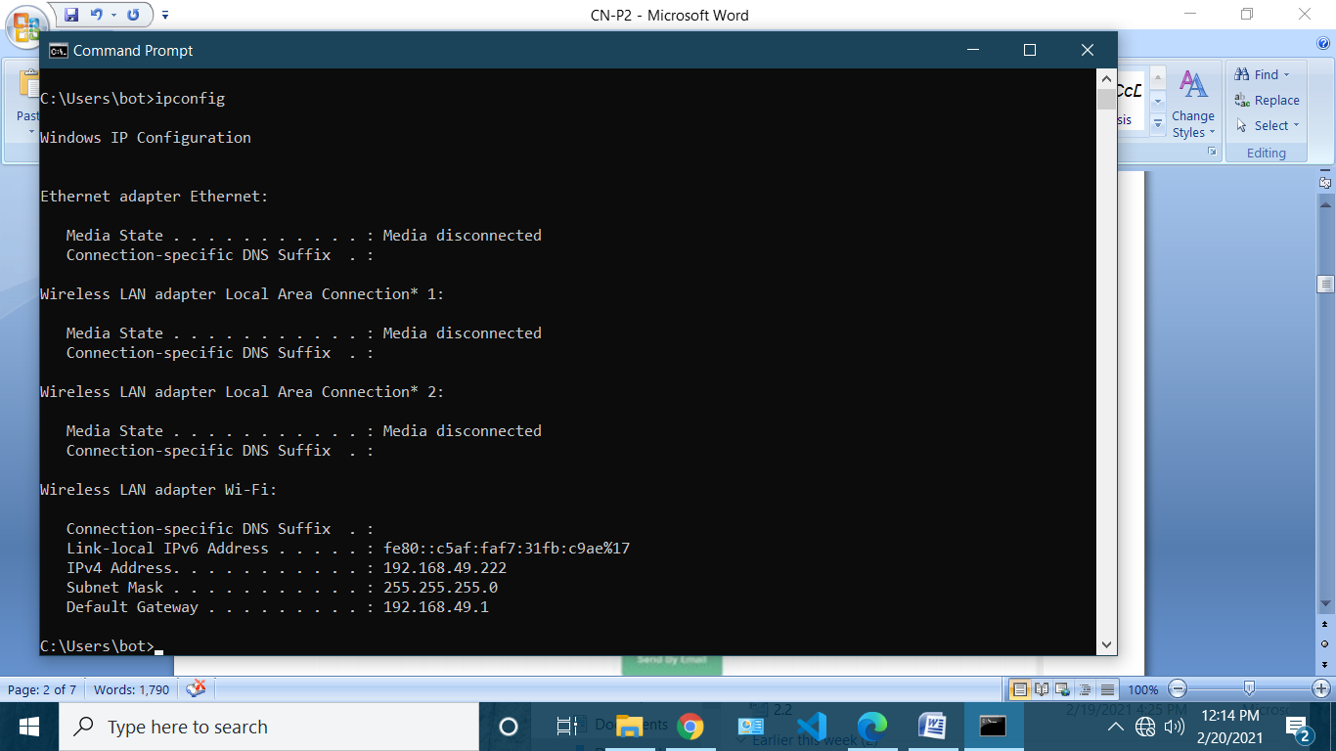**This is the private IP address of my system**

**Public IP Address**

**-** Your public IP address is the main IP address to which your home or business network is connected.

**-** This IP address connects you to the world, and it’s unique for all users.

**-** To find out your public IP address, simply go to https://whatismyipaddress.com/in your browser, and it will display the public IP, and other browser information.

**-**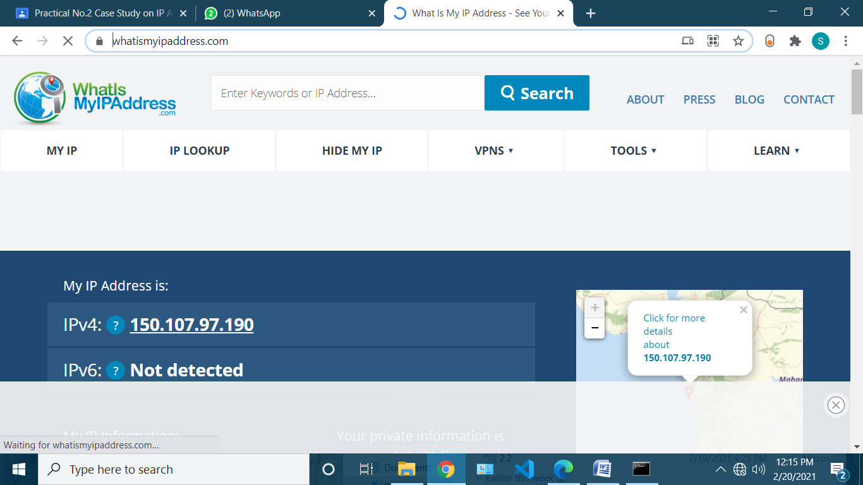

**This is the Public IP address of my ISP**

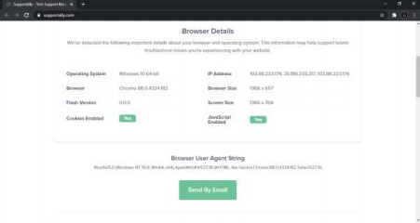

**Static and Dynamic IP Addresses**

**-** All private and public IP addresses can be either static or dynamic.

**-** IP addresses that you configure manually and fix them to the network of your device are called static IP addresses. Static IP addresses cannot change automatically.

**-** The dynamic IP address configures automatically and assign an IP to your network when you set up the router with internet. This distribution of IP addresses is managed by **Dynamic Host Configuration Protocol (DHCP)**. DHCP can be your internet router that assigns an IP address to your network in your home or business environment.

**Different Notations of IP Address**

**-** IP addresses are typically made of two separate components. The first part of the address is used to identify the network that the address is a part of. The part that comes afterwards is used to specify a specific host within that network.

**-** Where the network specification ends and the host specification begins depends on how the network is configured.

**-** IPv4 addresses are **32-bit addresses**. Each byte, or 8-bit segment of the address, is divided by a period and typically expressed as a number 0-255. Even though these numbers are typically expressed in decimal to aid in human comprehension, each segment is usually referred to as an octet to express the fact that it is a representation of 8 bits.

**-** A typical IPv4 address looks something like this: **192.168.0.5**

**-** The lowest value in each octet is a 0, and the highest value is 255.

**-** We can also express this in binary to get a better idea of how the four octets will look. We will separate each 4 bits by a space for readability and replace the dots with dashes: **1100 0000 - 1010 1000 - 0000 0000 - 0000 0101**

**-** We sometimes see an IPv4 address in hexadecimal notation. Each hexadecimal digit is equivalent to four bits. This means that a 32-bit address has 8 hexadecimal digits. This notation is often used in network programming.

**0x75951DEA**

**-** IPv6 expresses addresses as a **128-bit number**. IPv6 has space for more than 7.9×1028 times the amount of addresses as IPv4.

**-** To express this extended address range, IPv6 is generally written out as eight segments of four hexadecimal digits. Hexadecimal numbers represent the numbers 0-15 by using the digits 0-9, as well as the numbers a-f to express the higher values. A typical IPv6 address might look something like this:

**1203:8fe0:fe80:b897:8990:8a7c:99bf:323d**

**-** You may also see these addresses written in a compact format. The rules of IPv6 allow you to remove any leading zeros from each octet, and to replace a single range of zeroed groups with a double colon (::).

**-** For instance, if you have one group in an IPv6 address that looks like this: **...:00bc:...**

**Classful Addressing**

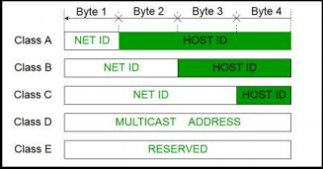

**-** IPv4 addresses were traditionally divided into five different “classes”, named A through E, meant to differentiate segments of the available addressable IPv4 space. These are defined by the first four bits of each address. You can identify what class an IP address belongs to by looking at these bits.

**- Class A**

**1.** 0—: If the first bit of an IPv4 address is “0”, this means that the address is part of class A. **2.** This means that any address from **0.0.0.0 to 127.255.255.255** is in class A. **3.** Class A addresses used the remainder of the first octet to represent the network and the

rest of the address to define hosts. This was good for defining a few networks with a lot of hosts each.

**- Class B**

**1.** 10–: Class B includes any address from **128.0.0.0 to 191.255.255.255**.

**2.** This represents the addresses that have a “1” for their first bit, but don’t have a “1” for their second bit.

**3.** The class B addresses used the first two octets (the remainder of the first, and the entire second) to define the network and the rest to define the hosts on each network. **- Class C**

**1.** 110-: Class C is defined as the addresses ranging from **192.0.0.0 to 223.255.255.255**.

**2.** This represents all of the addresses with a “1” for their first two bits, but without a “1” for their third bit.

**3.** The class C addresses used the first three octets to define the network and the last octet to define hosts within that network.

**- Class D**

**1.** 1110 : This class includes addresses that have “111” as their first three bits, but a “0” for the next bit.

**2.** This address range includes addresses from **224.0.0.0 to 239.255.255.255. 3.** Class D addresses are reserved for multi-casting protocols, which allow a packet to be sent to a group of hosts in one movement.

**- Class E**

**1.** 1111 : This class defines addresses between **240.0.0.0 and 255.255.255.255**. **2.** Any address that begins with four “1” bits is included in this class.

**3.** Class E addresses are reserved for future and experimental use, and are largely not used.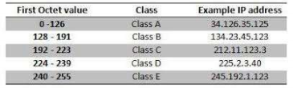

**PART 2:** Problem solving based on IPv4 address.

a. Change the following IP address from binary notation to dotted-decimal notation. 10000001 00001011 00001011 11101111

**Solution: 129.11.11.239**

b. Change the following IP address from dotted-decimal notation to binary notation: 111.56.45.78

**Solution: 01101111 00111000 00101101 01001110**

c. Find the error in the following IP Address

111.56.045.78

**Solution: Byte 3 i.e. the third octet begins with a 0 which is not a valid 8bit decimal number** d. Find the error in the following IP Address

75.45.301.14

**Solution: Byte 3 has a value 301 that does not belong to octet number (Octet includes numbers from 0-255)**

e. Change the following binary IP address to Hexadecimal notation

10000001 00001011 00001011 11101111

**Solution: 0x810B0BEF**

f. Find the class of the following IP addresses

a. 00000001 00001011 00001011 11101111

b. 11000001 00001011 00001011 11101111

**Solution:**

**a. Class A**

**b. Class C**

g. Find the class of the following addresses

a. 158.223.1.108

b. 227.13.14.88

**Solution:**

**a. Class B**

**b. Class D**

h. Change the following IPv4 addresses from binary notation to dotted-decimal notation. a. 10000001 00001011 00001011 11101111

b. 11000001 10000011 00011011 11111111

**Solution:**

**a. 129.11.11239**

**b. 193.131.27.255**

i. Change the following IPv4 addresses from dotted-decimal notation to binary notation. a. 111.56.45.78

b. 221.34.7.82

**Solution:**

**a. 01101111 00111000 00101101 01001110**

**b. 11011101 00100010 00000111 01010010**

j. Find the error, if any, in the following IPv4

a. 111.56.045.78

b. 221.34.7.8.20

c. 75.45.301.14

d. 11100010.23.14.67

**Solution:**

**a. Byte 3 begins with a 0 which is not a valid 8bit decimal number**

**b. The address exceeds the 32 bit limit, hence it is not valid.**

**c. Byte 3 has a value 301 that does not belong to octet family (Octet includes numbers from 0-255)**

**d. It is a mixed format of decimal and binary numbers and thus is not valid** k. Find the class of each address.

a. 00000001 00001011 00001011 11101111

b. 11000001 10000011 00011011 11111111

c. 14.23.120.8

d. 252.5.15.111

**Solution:**

**a. Class A**

**b. Class C**

**c. Class A**

**d. Class E**